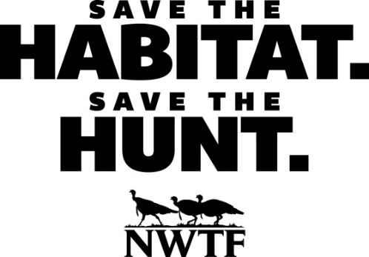
December, 2018
Dear MI NWTF Chapter Presidents, Committees, and Members,
We hope you are enjoying winter in MI, especially as you prepare for Christmas and the New Year. As you know, the MI State Chapter Convention comes in January. This fun event is January 18 and 19, 2019 at the Holiday Inn, Big Rapids. We hope to have every local chapter in MI represented this year. We have so much to celebrate! We need your participation to make this a successful event.
We start on Friday with hospitality from 6 till 11 PM. We have snacks, a cash bar, and tables for games. It’s a good time to reconnect with friends and relax with NWTF staff and volunteers. Steve Sharp will offer a mentoring workshop during this time. On Saturday, the Board of Directors will meet from 9:00 till 1:00, and all are welcome to attend. At 2:00 to 3:30 PM we have 3 planned speakers: Ross Melinchuk, NWTF Executive VP of Conservation; Al Stewart, MI DNR Upland Game Bird Specialist; and Steve Sharp, NWTF R3 Coordinator. Each has a unique and interesting presentation on turkeys with an emphasis on our current initiative “Save the Habitat”, “Save the Hunt”.
At 4:00 the doors open for the MI State Chapter banquet, featuring the new 2019 Core Package, raffles and games. See our ticket page for prices and special raffle deals. The raffle deals must be bought by January 12, 2019 and will be picked up at the door. Reserve your tickets by mail or phone, or use the web page www.minwtf.org.
To make this banquet successful, we need your chapter to contribute by giving a donation or a check. Specifically, we want a product or service unique to your area or a check for $100- $200 to NWTF sent to Jan Kuhtic, 255 133rd Ave. Wayland, MI 49348. Your chapter will be acknowledged in the program, at the auction, and on the item donated. Please tell us what you plan to give by January 12.
To reserve a room, call the Holiday Inn at 231-796-4400 and tell them we are the NWT group. Or use this link which will bring you directly to the $92.00/night rate, click the dates you wish to stay and use the code NWT: https://www.holidayinn.com/redirect?path=hd&brandCode=HI&localeCode=en&regionCode=1&hotelCode=BRPMI&_PMID=99801505&GPC=NWT&viewfullsite=true
Note that the discounted rate is good until December 29, 2018.
This banquet celebrates the phenomenal work we have accomplished together with our many partners. Many chapters contributed to these successes, and we need to give proper thanks and recognition. As you read this letter, take the time to notify your chapter leaders about this event, and make plans to attend.
Sincere thanks,
Tom Karsten, NWTF Regional Director, and Phil & Jan Kuhtic, Convention Chairs

